THE BASIC NETWORK:
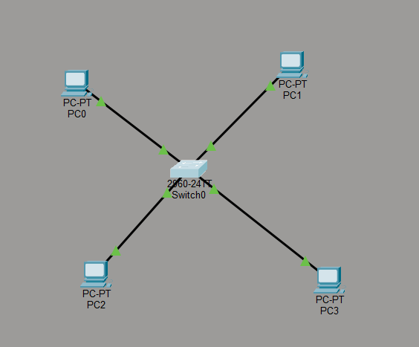

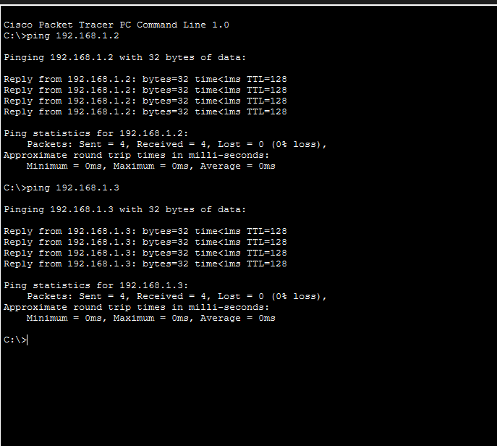
Ping command to check connectivity between packets

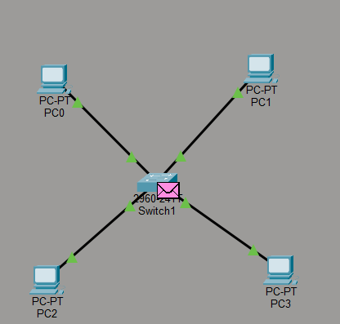
Packet Flow can be seen, how it is taking place

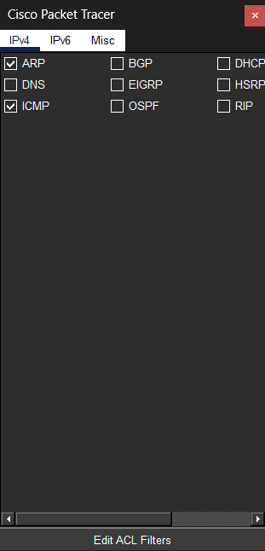
In edit filter ARP AND ICMP are selected.
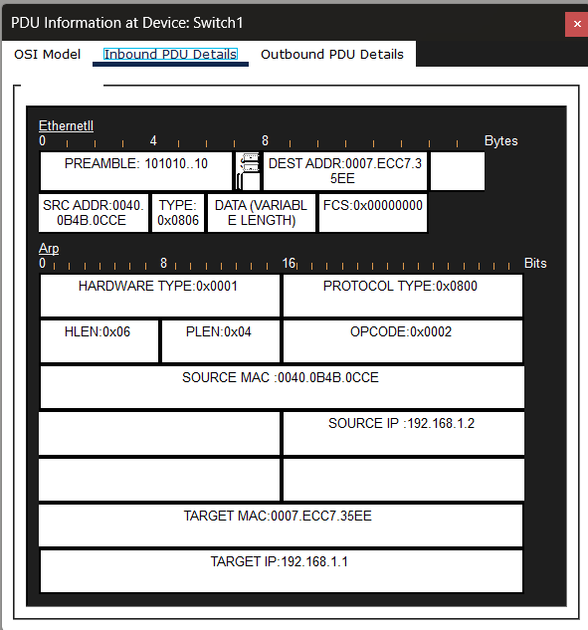

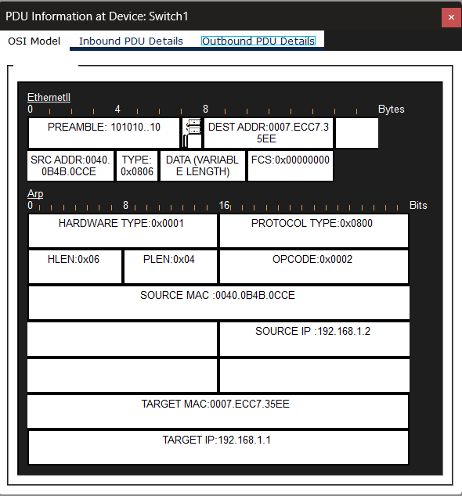

The Ethernet frames were successfully analyzed by comparing the Inbound and Outbound PDU details. Since the Source MAC (0040.0B4B.0CCE) and Destination MAC (0007.ECC7.35EE) remained consistent as the frame transitioned through the switch, it confirms that the switch is operating correctly at Layer 2, using its MAC address table to provide point-to-point delivery without altering the frame header.

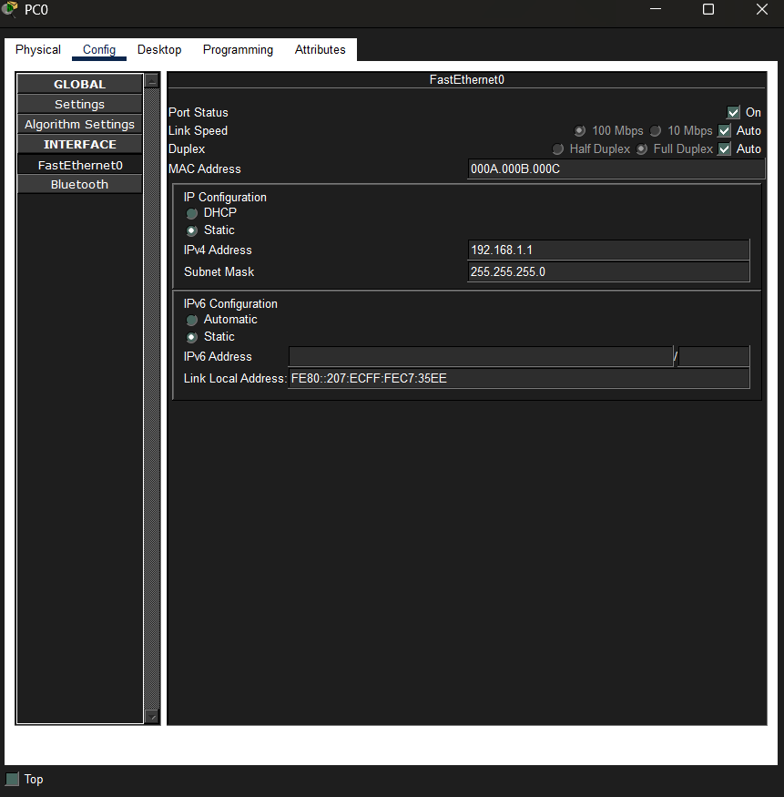
MAC ADDRESS CHANGED FOR PCO

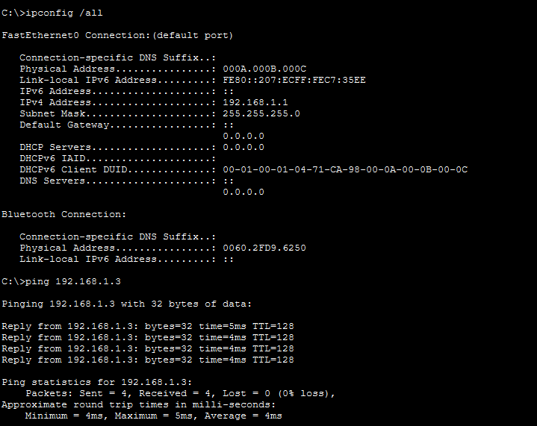
After changing the MAC address of PCO, we can see the changed physical address of PC0 using ipconfig /all and ping command to view the connectivity from PC0 to PC2

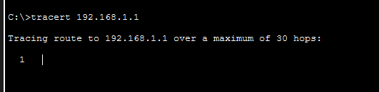
The tracert command resulted in a single hop. This confirms that the devices are within the same broadcast domain and that the switch is performing Layer 2 forwarding without the need for a default gateway or router.

